School Clubs Brochure
Autumn Term
2026

Please read this document in conjunction with the club timetable. Please follow the booking instructions carefully, and note the age range of the club before requesting a place for your child.

Welcome to the Oratory Breakfast club


Join us for a nutritious and fun start to the school day with our new Breakfast Club!
The children can participate in some calm activities with their friends (reading, board games, colouring) whilst enjoying a healthy breakfast ensuring they’re set up for a great day.

Breakfast Club:

- You must book a place in advance by sending an email breakfast@oratory.rbkc.sch.uk. Payment must be made in advance on your ParentPay account to have a confirmed place. An email will follow to confirm your child’s place.

- Booking can be made for a whole week / term or parents/carers can specify the exact days of the week required.

- You must arrive between 8:00 – 8.15 a.m. (no entry after 8.15 a.m.)

- Cost - £3.50 per day (sibling/s charged at £2.50 per day).

Location
Breakfast Club will be held in the School Hall. Please enter through the main green door by the School Office.

Menu
Children will be offered a healthy breakfast such as, cereal, toast, fresh fruit and milk to ensure they have a great start to the day.


We believe that every child should have the opportunity to play music. We would like to offer your child the chance to learn a musical instrument during school hours.
Lessons are open to all children from Reception to Year 6. This club is fully booked at the moment with existing students however, please contact the provider to add your child to the waiting list.

Guitar, Piano or Violin - will be taught on a one-to-one basis by visiting professional tutors and all teaching materials will be provided. Each pupil will receive 10 lessons per term - lessons are booked in and paid for at the beginning of every new term and half term. The tutors will collect the child from their classroom and lessons will take place in our music room.
Instruments will be provided by Piano Fun Club (there will be an opportunity to purchase the instrument if your child continues lessons next academic year).

Stage 1 lessons: 1 x 15-minute lessons weekly (beginners)
Stage 2 lessons: 1 x 20-minute lessons weekly (intermediate)
Stage 3 lessons: 2 x 15-minute lessons weekly (advanced)

If you would like your child to have music lessons or would like further information, please contact Piano Fun Club directly.

www.pianofunclub.co.uk

admin@pianofunclub.co.uk

07932 596 192
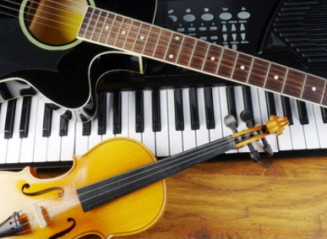
Chess Club

Founded in 2015, we are a local chess club that is active in Kensington and Chelsea. We run school clubs as well as organising tournaments, holiday camps and weekly clubs. Over the years we have trained several children who have gone on to represent their country in international tournaments and many who have developed a deep appreciation for the game.

Chess can be beneficial in teaching important life skills such as: dealing with wins & losses, planning ahead, accountability for actions, analysing, reflecting and improving, learning to focus.

Provider: South West London Junior Chess Club
Contact: toni@swchess.co.uk
Website: www.swchess.co.uk
Cost per session: £10 for After School Club (Tuesday) & £7.50 for Lunch Time Clubs (Monday & Thursday). Fee paid in advance for the term.
Beginner club: For children new to chess. Children will learn how the pieces move and capture and then move onto concepts such as the difference between check and checkmate.
Intermediate/Advanced Club: For children that know how the pieces move and capture and can set up a basic checkmate. Children will learn how to use tactics (short term tricks) and strategies (long term plans) that will help them to win a game of chess.

There might be some movement from beginners’ group to intermediate/advanced group at the start of the new term.

KS2:
Monday lunchtime
For Y3, Y4, Y5, Y6
KS1 Chess:
Thursday lunchtime
For Y1 & Y2



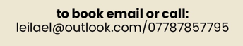

Monday lunchtimes
Years 3-6
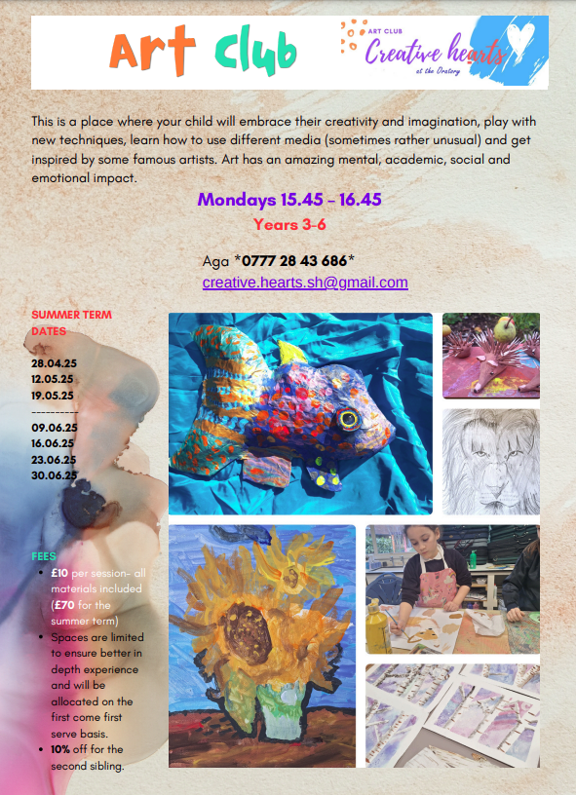

Please complete the enrolment form if your child is interested in joining the club

Cookery Club
In cookery club the children will learn how to make simple recipes such as smoothies and wraps. The club runs for five weeks and is small, just 6 children, so that each pupil can have attention and supervision in order to develop simple skills. All children will have the opportunity to take part if they wish. A letter will be sent at the beginning of the Autumn term and dates sent out shortly afterwards.

By invitation from Ms Fyers



Choir
Choir will offer the opportunity for children to develop self-confidence through song. The children will take part in vocal warm up exercises, sing a range of songs, learn to sing in harmony, and take part in a number of performances throughout the year.

Mrs Steinart
No charge
For Y3, Y4, Y5, Y6
Informal selection


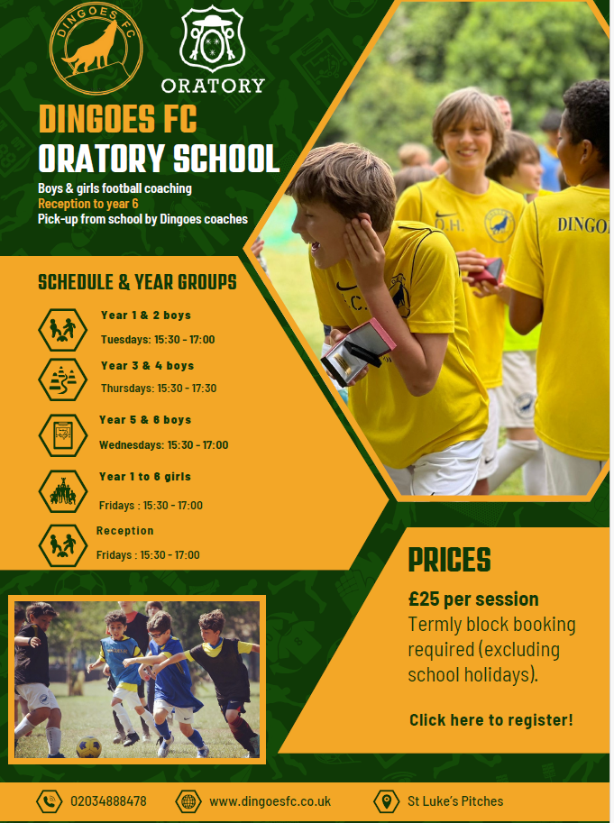
Register here
Click here to register

Football and Netball Leagues

The local leagues are perfect for children who enjoy teamwork, love being active and improving their sports skills. Both leagues are mixed, for boys and for girls. Children will practise with school staff during lunchtime, before meeting teams from the local area on match days.
RBKC league including Football, Hockey, Handball and Netball for Years 5 & 6

Letters will be sent at the start of term




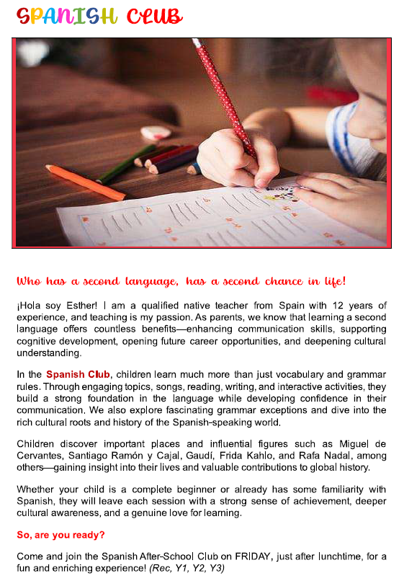


Italian Language After School Club

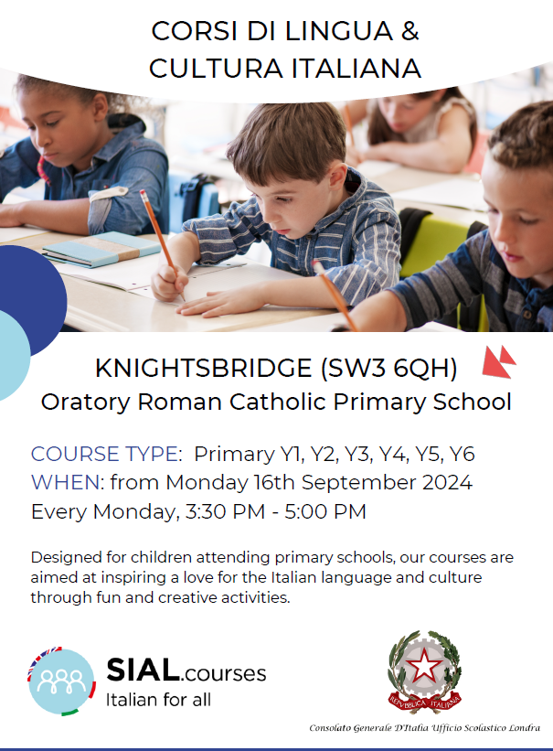
9th September 2025

ENROL NOW
After-school Italian courses in Knightsbridge - SIAL.courses

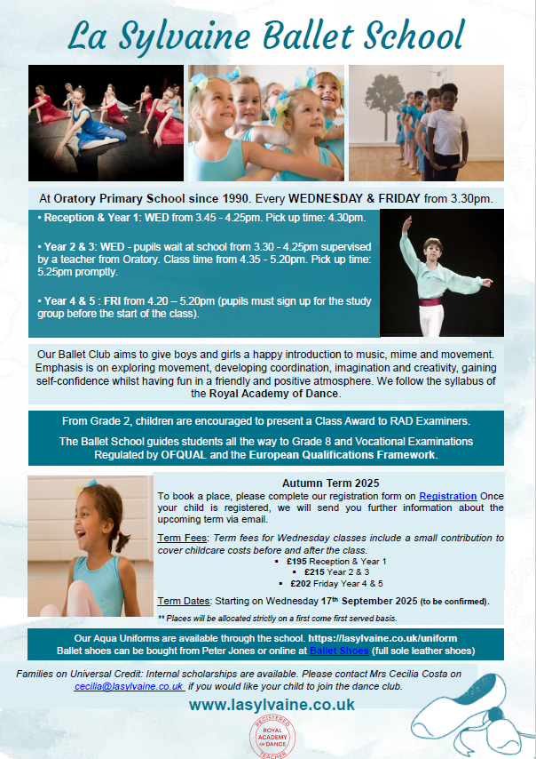
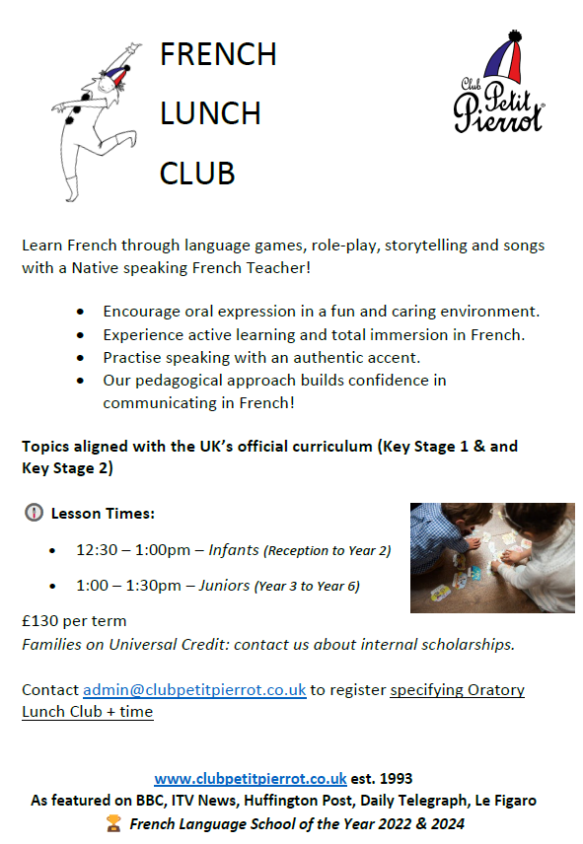



DH-SPORTS SPORTS COACHING

To Parents/Guardians,
We are delighted to inform you that we will be providing Sports Clubs at Oratory School for the upcoming 2025/26 School year! With the clubs being a great success so far, we are delighted to be coming back. At DH-Sports we have fully qualified and experienced PE specialists who aim to make playing Sport as fun as possible.
The clubs we will be running in the Autumn Term are:
Club | Year Groups | Day/Time | Price
Netball | Y2/Y3/Y4/Y5/Y6 | Monday  8.00-8.45am | £71.50 (13 weeks)
Football | Y3/Y4/Y5/Y6 | Tuesday  8.00-8.45am | £77 (14 weeks)
Girls’ Football | Y2/Y3/Y4/Y5/Y6 | Wednesday  8.00-8.45am | £82.50 (15 weeks)

Please arrive at the office door at 8.00am promptly where the coach will open the door for you.
You can now book your child onto our clubs by using our new quick and easy booking system. Click the link: https://dh-sports-coaching.classforkids.io
You will also find booking details for our Summer Holidays Football Camps.
If you would like to book a place for your child. please email: dhsportscoaching1@gmail.com
Kind Regards
Dean Henwood


.
Welcome to the Autumn 2025 Term of After School Clubs at Oratory Roman Catholic Primary School! We're excited to bring you our Mini Coders club. You can read more about the course down below.

In this club, students will learn to use digital tools to bring their imaginations to life. They will create a series of interactive art pieces and animations, broadening their creative palette while gaining valuable digital skills. A highlight of the course is the opportunity for students to create their own LEGO animations. Using stop-motion animation techniques, they will build their own LEGO scenes and characters, then animate them to tell unique stories. This hands-on activity will not only enhance their technical skills but also encourage imaginative storytelling and problem-solving. By the end of the course, students will have a portfolio of digital artworks and animations that showcase their creativity and newly acquired skills.

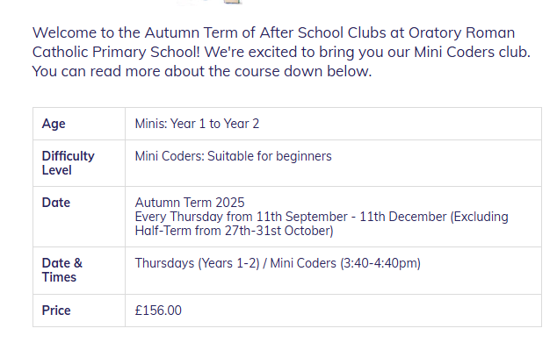

To book your place please visit
https://blueshiftcoding.com/products/oratory-primary-school-after-school-clubs

Website: https://blueshiftcoding.com Any questions: hello@blueshiftcoding.com
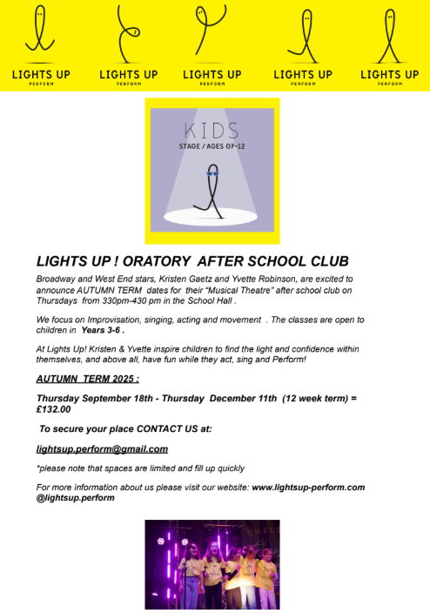

German Language After School Club


This After School German Club is aimed at Year 1 to Year 4 and it is for both native and non-native speakers.

The club takes place every Tuesday from 3:40-4:40pm

The aim of the Club is for the children to enjoy learning German in a fun and stimulating environment through songs, short videos, games and interactive whiteboard activities. The main focus also being to develop cultural awareness of aspects of life in Germany. Two puppets will also keep the children entertained by inviting them to sing songs and modelling role plays.

English and German have many common words, structures and practical similarities. Children will also find speech sounds very similar to English. All of this will help pupils to learn German by building vocabulary very quickly and get them speaking.

Contact: Sonja Schmitt (native German speaker) / soniaschmitt@hotmail.com

Drawing
Drawing club aims to instil a love of art in children. They will be taught to draw a range of subjects with confidence, exploring different techniques for composition and shading.
Members of the club will be chosen on a rota basis across the academic year, from children who show an interest and wish to take part.

Ms Nuttall
Lunchtime
No charge
Informal selection





Active Day Camps offers a unique, bespoke and high-quality range of after school clubs throughout London. Since our launch in 2016 we have built a strong reputation as a safe, fun and nurturing environment. Our diverse range of clubs and activities offer children the chance to put their own stamp on their time with us – always having the choice at the start of each session between two activities. This choice not only makes the week personal to each child, but it encourages independence and decision making. Our programme involves a mixture of Sport, Art & Drama.
Every day for all year groups
First session: 3.30pm – 4.30pm
Second session: 4:30pm – 6:00pm

Link:
https://activedaycamps.thinkbooker.com/booking/search?group=Wraparound%20Clubs

Active Day Camps Office phone number/email:
02078460253
enquiries@activedaycamps.com
Discounts:
25% off for staff using code: oratory25
50% Pupil Premium: pupilpremium50
10% sibling discount using code: sib10

